**LYNFIELD COLLEGE**

**2025 STUDENT ASSESSMENT COVER SHEET**

|  |  |  |  |  |  |  |  |  |
| --- | --- | --- | --- | --- | --- | --- | --- | --- |
| **Course Title** | | | | **2PAD** | | | | |
| **91897: Use advanced processes to develop a digital technologies outcome** | | | | | | | | |
| **Achievement Standard** | 91897 | **Level** | 2 | | **Version** | 1 | **Credits** | 6 |

**Due Date: Term 3, Day 9, Week 2 (24 July 2025)**

**Achievement Criteria:**

|  |  |  |
| --- | --- | --- |
| **Achieved** | **Merit** | **Excellence** |
| Use advanced processes to develop a digital technologies outcome. | Use advanced processes to develop an informed digital technologies outcome. | Use advanced processes to develop a refined digital technologies outcome. |

**Authenticity statement**:

The work that I have submitted for this assessment is my own.

I understand any material used and/or quoted that is not my own must be acknowledged in the appropriate manner. I understand that the use of chatbots, generative AI, paraphrasing tools, or other tools that can automatically generate content is not permitted. Material generated by these tools has not been included in this submission.

I understand any material used and/or quoted that is not my own must be acknowledged in the appropriate manner.

I have acknowledged all direct quotes and references used in this assessment.

I understand that plagiarism and/or collusion with other students may result in disciplinary action and a Not Achieved grade being given.

If submitting a digital copy of this assessment I agree to the above.

I give permission for my assessment to be given to the external assessor for marking.

**STUDENT’S NAME: Lee DATE: 05/06/2025**

`

**STUDENT’S SIGNATURE**: **DATE: 05/06/2025**

**Grade awarded:**

|  |  |
| --- | --- |
| **Not Achieved** | **Achieved** |
| **Merit** | **Excellence** |

**TEACHER’S SIGNATURE** .........................................................

**Instructions**

* Read all instructions carefully.
* Complete **ALL** tasks.
* Ensure your name is on every page of your assessment.

**Conditions**

* The timeframe for completion will be set by your Assessor according to a particular classroom situation.
* You must follow legal ethical and moral responsibilities when creating your documents.

**Note to Assessors:**

You will need to provide candidates with a copy of the documented policies and procedures or commonly accepted practices of your organisation, prior to being assessed against this achievement standard.

**Context/Te Horopaki**

This is an integrated assessment activity supporting a project-based approach that assesses against two achievement standards. Students will use advanced processes to plan, test and trial a party hire store program. They are required to implement advanced programming techniques within their hire program.

Using advanced processes will support the students to develop a refined party hire program that has been comprehensively tested and debugged. Both achievement standards require testing to improve the quality and functionality of the outcome.

Students will use python programming language and tkinter, as it supports a range of advanced programming techniques.

**Conditions/Ngā Tikanga**

You will be given two identified checkpoints with as you work through this assessment activity to ensure they have an opportunity to ask questions and gather feedback.

**Resource requirements/Ngā Rauemi**

Students will need access to software that will allow them to document their development process. This could be in the form of a document, testing document or google slides.

They will also need access to project management and version control tools (which may include a mixture of digital and non-digital resources).

The format of the final outcome is a computer program.

Students will need to supply evidence of using recognised and appropriate project management tools and techniques to plan and manage the development of the computer program. This will include trialling and testing the components of the program (see student task for more details).

**Achieved**

**Use advanced processes to develop a digital technologies outcome involves:**

* using appropriate project management tools and techniques to plan the development of a digital technologies outcome.
* decomposing the outcome into smaller components
* trialling the components of the digital technologies outcome
* testing that the digital technologies outcome functions as intended
* explaining relevant implications.

**Merit**

**Use advanced processes to develop an informed digital technology outcome**

**involves:**

* effectively using project management and version control tools and techniques to
* manage the development of a digital technologies outcome.
* trialling multiple components and/or techniques and selecting those which are
* most suitable
* using information appropriately from testing and trialling to improve the
* functionality of the digital technologies outcome
* addressing relevant implications.

**Excellence**

**Use advanced processes to develop a refined digital technologies outcome involves:**

* discussing how the information from planning, testing and trialling of components assisted in the development of a high-quality outcome.

**Below are some examples of project management and version control tools and techniques and relevant implications.**

*Examples of project management and version control tools and techniques include:*

● saving backup copies with a logical file naming system

● using collaboration tools

● using simple version control software applications

● using tools or systems to plan tasks and milestones

● adjusting key actions and tasks where appropriate

*Examples of relevant implications include:*

● social

● cultural

● legal

● ethical

● intellectual property

● privacy

● accessibility

● usability

● functionality

● aesthetics

● sustainability and future proofing

● end-user considerations

● health and safety.

**Planning Tools may include:**

The template gallery in Google Sheets has Project Management tools for drafting up a plan. They are Gantt Chart, Project Timeline, and Project Tracking. Complete your own research to find a tool that suits you.

**Gantt Chart** – this is a bar chart that tells a visual story. It is like a visual to-do list. Filling in cells with different colours, using clear labels and headings and breaking down tasks into small chunks helps to determine a robust workflow.

**Project Timeline** – this is similar in looks to a Gantt Chart. It has clear stages.

**Project Tracking** – this tool is less visual. It works with task descriptions, start and end dates.

**Trello Board:** progress tracking with your milestones.

**Task size table:** estimate of how long your task is.

*Also refer to the training education website for more examples. Ask your teacher for any assistance on this.*

**Other Resources**

**Project Management Tools and Techniques:**

A project has a beginning and an end with lots of steps (tasks, processes) that are completed at various points along the project timeline. In this context, project management tools and techniques are used to document the process of **outcome development**. Project Management involves planning the steps to take and documenting them as they are taken. Progress is tracked and end users are consulted.

It is important that you do your own research to find a project management tool that suits your workflow. From the standard, examples of project management tools and techniques include:

• Agile or waterfall techniques

• Kanban

• Version control software

• Collaboration tools

**NOTE 1: It is not a requirement that you utilise all of these techniques and tools. It is up to you what you use. However, you must use at least one tool to manage your project and Justify it.**

**NOTE 2: Check the usability of your Project Management Tool. Some tools offer you 30 days free, others restrict the number of cards/boards you can use.**

**Techniques:**

**These are software development methodologies.**

**Agile** – continuous iteration. Changes allowed in the project.

**Waterfall** – sequential order. The project only moves forward if the previous step or phase is complete. Simplest technique for small projects.

https://www.youtube.com/watch?v=egF9-FejbsA

Tools:

**Kanban** – Kanban is a visual process and project management tool.

**Version Control** – saving each iteration as the outcome is developed allows the designer to revisit an earlier version at any time.

**Collaboration Tools** - examples include Trello, Padlet, Figma, Microsoft

Teams, Microsoft Tasks, Microsoft ToDo, Fleep, Monday.com. These can be used to showcase your development for feedback from end users. Google Forms can be used to gather feedback, or a questionnaire created in other software such as Microsoft Word. Choosing the right collaborative tool is important for sharing your development with end users and collecting feedback. Slack, for example, can be integrated with Google Forms.

Google Forms are one way of questioning end users. Responses are automatically collated in a Google Sheet.

**Trial and Test**

* For each component, trial and test with end users
* Repeat the cycles of trialling (gather information) and testing (make decisions) until you are satisfied that you have iterated enough to have a high-quality outcome.

**Reflection**

Create a document and save it as ‘Reflection’. Set up headings and discuss the questions as outlined below.

* How has the combination of planning, utilising project management tools, collaboration tools, and feedback tools helped you to create a high-quality outcome?
* How has the information you have gathered from the planning, trialling and testing of components lead to the creation of your final outcome?
* How have you addressed your relevant implications in your final outcome?

*The below questions allow you to follow a structured way of approaching the AS91897. Note that where it says (Add answer here) an answer is required. In order to receive an achieved in this project all questions must be answered at a reasonable level (more than just one sentence).*

Concept designs (Sketches/Drafts):

**Concept 1**

I like this design because it looks aesthetically pleasing. This design also has an easy-to-use user interface. The design allows everything to flow efficiently.

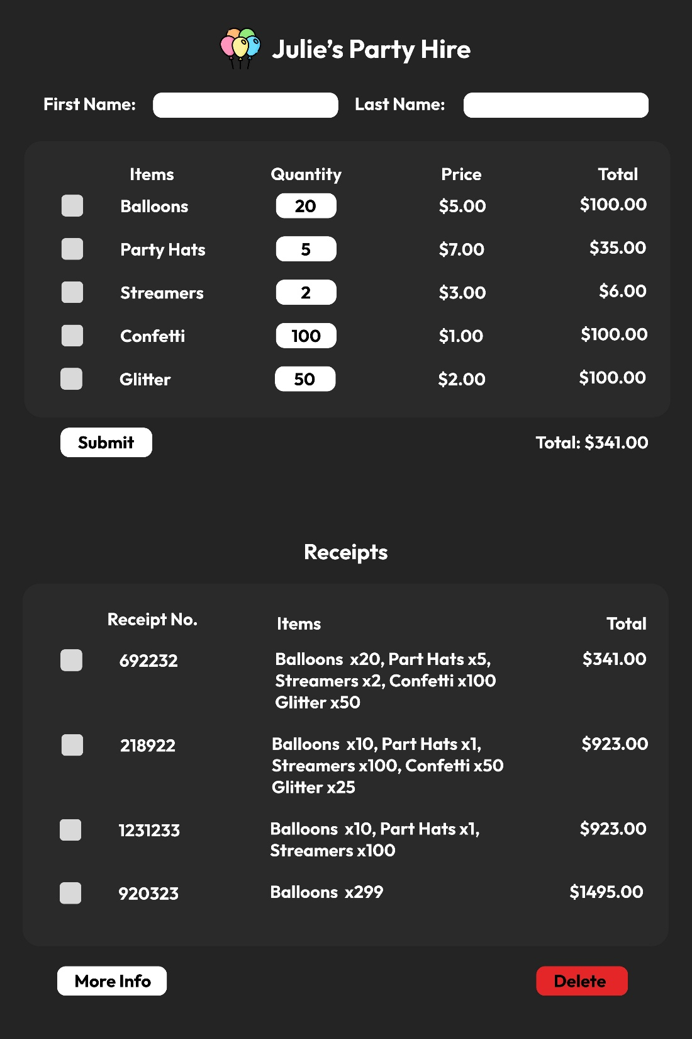

**Concept 2**

I like this design because it is compact and fast to use. It also has an extremely easy to use user interface.

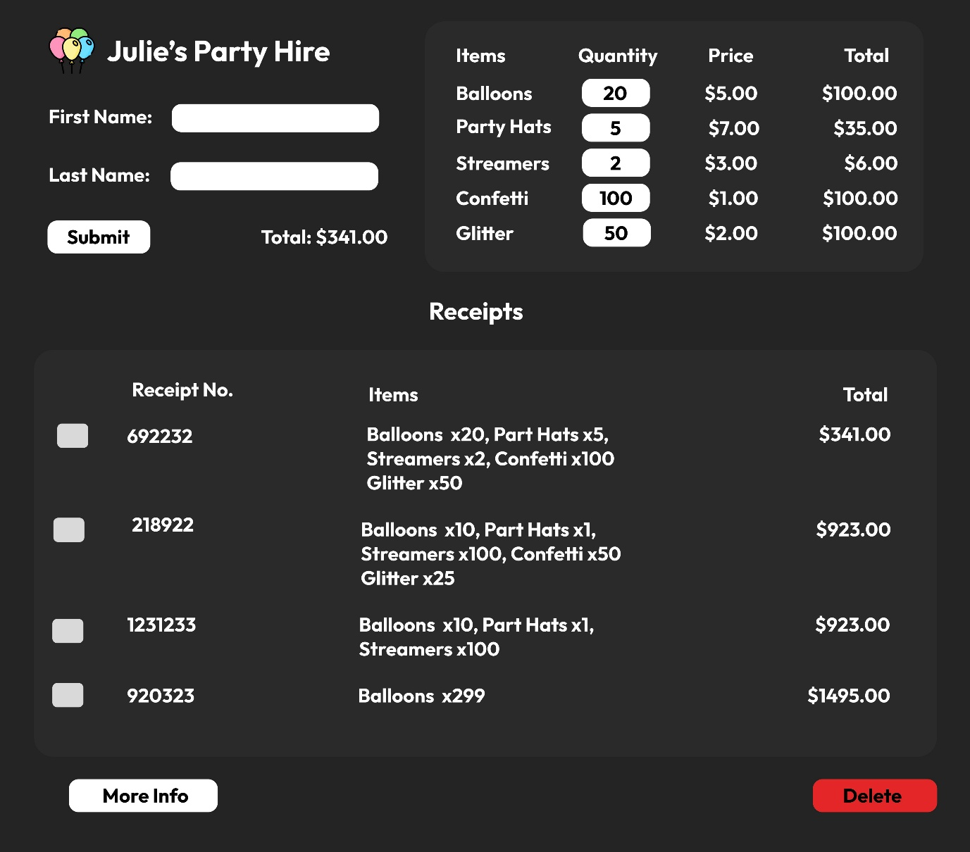

**Concept 3**

Utilizes the width of the display instead of the height for easy viewing

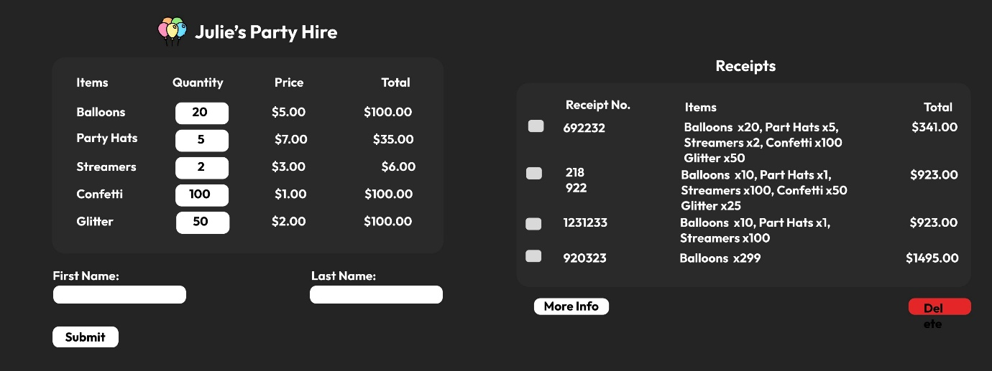

**Final Concept**

I chose concept 1 as it is the easiest to understand and use. It is easy to understand because of the way it’s laid out from top to the bottom. It is easy to use as there are minimal buttons, and that also prevents mis-clicking from the user.

Concepts 2 and 3 are too compact and can result in mis-clicks.

The stakeholders think that concept 1 is very neat and tidy and is very structured and easy to use and understand.

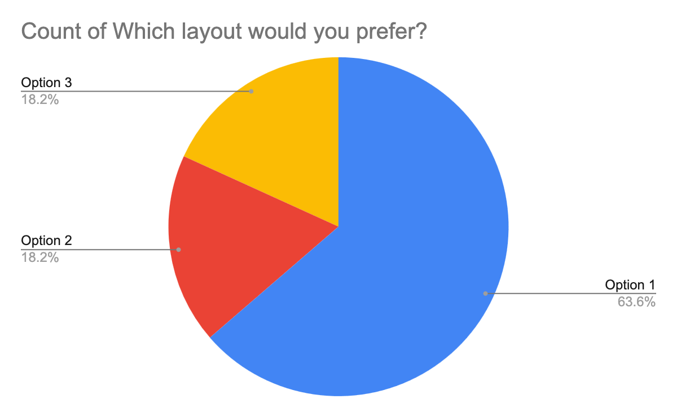

|  |  |  |
| --- | --- | --- |
| **Timeline** | | |
| Date | Screenshot(s) | Description |
| 07/05/2025 |  | Research methodologies:   * Agile * Waterfall * Kanban   Watched LMS videos on all 3 of the methodologies  Set timeline for the setup of planning tools and project management (the card in the screenshot) |
| 08/05/2025 |  | Finished brainstorming ideas and concepts.  Made concept 1, 2 and 3 on [Figma](https://www.figma.com/design/7nqq19z34IUmida28VTd3K/LIN--Lee---Concept-Designs--2PAD---AS91897-?node-id=0-1&t=AeQGKjxa5Kcx0cGf-1) |
| 13/05/2025 |  | Added onto the composition table  Started and finished researching methodologies (on LMS) |
| 14/05/25 |  | Researched version control tools  Setup Github version control.  Google forms and google sheets (to display the data in) created  Update trello and Gantt Chart |
| 15/05/25 |  | Made simple layout and trialled different elements/ |
| 16/05/25 |  | Added the title element.  Trialled element.  Updated Gannt Chart and |
| 21/05/25 |  | Added first name and last name fields. |
| 26/05/25 |  | Started on item checkboxes. |
| 26/05/25  -  17/06/25 |  | Added all the items. |
| 17/06/25  To  31/06/25 | Make the program use Object orientation.  Because there is a lot of repetition in the items, I decided to make the program object orientated.  I re-implemented all the components into a class. |  |
|  |  | Add a submit button.  Updated charts  Added new item to google forms |
| 05/07/25 |  | Added validations |
| 10/07/25  -  20 |  |  |
|  |  |  |
|  |  |  |
|  |  |  |
|  |  |  |
|  |  |  |
|  |  |  |
|  |  |  |

Project Management Techniques (Methodologies):

I have chosen these project management techniques to research:

* Agile
* Kanban
* Waterfall

Agile divides work into phases, stressing the importance of continuous delivery of code and improvement of code. Agile allows teams to plan around certain times and enables them to rapidly code and evaluate. It leads to a more responsive and successful outcome.

Kanban is a framework used to implement Agile. It needs on-going communication and tracking of each team member to see what they are up to. To-do items / work items are represented visually on a kanban board, enabling team members to see each stage of every piece of work at any given time.

Waterfall is a smooth, less intensive workflow. Similar to a waterfall, each process / phase goes downwards in a sequence through 5 stages (requirements, design, implementation, verification, and maintenance).

**I chose to do Agile because I can rapidly adapt my program easily. These documents/websites help me achieve those goals:**

* Trello Board

I chose the Trello board because it helps me organize steps easily and visually demonstrates what I need to do, and what I’ve done. This leads to a more streamlined workflow.

(<https://trello.com/invite/b/680ec28ad2cf154b8fc3428f/ATTIe58195d338dfd33016d0db380f1aee22CD9B262A/lin-lee-as91897>)

* Gannt Chart

I used a Gannt chart to track each step’s progress carefully. I can use it to help track where I am at and what parts I need to work on the most, while maintaining a consistent workflow.

I used an online Gantt chart: [https://app.teamgantt.com/projects/gantt2?ids=4272742](https://app.teamgantt.com/projects/gantt2?ids=4272742&focusDate=2025-05-15)

Collaboration Tools:

I’ve decided to research the following collaboration tools:

* Google Forms
* Figma
* Microsoft

Microsoft Forms allows users to create custom surveys, quizzes, polls and questionnaires.

Figma Design is for people to create, share, and test designs for websites, mobile apps, and other digital products and experiences. It is a popular tool for designers, product managers, writers and developers and helps anyone involved in the design process contribute, give feedback, and make better decisions, faster.

Google Forms allows users to create and edit surveys online while collaborating with other users in real-time. The collected information can be automatically entered into a spreadsheet

**I chose to use google forms because it is simple to use, and the results can be easily exported into a google sheet (which I will use to share the results (graphs))**

**Form:**

<https://docs.google.com/forms/d/1Q7UH0ZH41DcS8c_rrkDZCQbsRYPepgpnk1cdO9oegnY/edit>

**Spreadsheet to display my feedback in. The spreadsheet is linked to the google forms allowing easy modifications and live updates**

<https://docs.google.com/spreadsheets/d/1v5Vvw98Ozwn2yDbNc1fDXnuaGwubycDJmt_JRGthYsw/edit?usp=sharing>

Version Control:

I’ve decided to research the following version control tools:

* File explorer
* GitHub

File Explorer is a built-in file system management application included in Windows. It allows users to create, remove and modify files and folders.

GitHub is an online platform where you can log your documents and all the changes online onto their website

**I have used GitHub as my version control because it is simple to use and very popular. In addition to that, all the files are stored online and are accessible via a browser. It is easy to go back to previous versions of the code if something happens, and I can develop different parts of the program in different branches of the repository and then merge them easily.**

*GitHub Repo*

[*https://github.com/poggersv2/Lee_AS91897_AS91896*](https://github.com/poggersv2/Lee_AS91897_AS91896)

Decomposition Tools:

* Decomposition Table / Word document

I chose this because it’s easy to manage the components, and a table is an orderly way to show tasks and can be made in most common document formats. It is useful as a reference and guides you along the right path. It is simple to understand and easy to implement.

Refer to Word file in this folder ([LIN, Lee - Decomposition Table (2PAD - 91986 and 91987).docx](https://lynfield-my.sharepoint.com/:w:/g/personal/23040_students_lynfield_school_nz/EYVRSpggJgtPvfLMIPD7jj8BUnIJA0PjzikHaXCw3QghZA?e=TjhZ5j))

Concept Creation:

* Figma

I used Figma to design my concepts because it effectively shows my designs, compared to wireframes, which are too approximate. Using Figma, I can create exactly what I am thinking.

(<https://www.figma.com/design/7nqq19z34IUmida28VTd3K/LIN--Lee---Concept-Designs--2PAD---AS91897-?node-id=0-1&t=AeQGKjxa5Kcx0cGf-1>)

*Testing tables are a way of testing my inputs and outputs. This is extremely important because the whole program relies on them.*

Testing Table is in the same folder as this document.

[LIN, Lee - Testing Table (2PAD - 91986 and 91987).docx](https://lynfield-my.sharepoint.com/:w:/g/personal/23040_students_lynfield_school_nz/EXDHnY228oRKhND7UnqIwQUBO_MeikE4a-FLgIUTxbOsxA?e=mSuUTH)

|  |  |
| --- | --- |
| Component 1: Windows / Colour Scheme | |
| Trialling : | Dark mode,    Light mode,    Transparent, |
| Evaluation of Response: | I decieded to use the transparent theme because most of the feedback leaned towards a transparent window beccause it was aesthetically pleasing and was very cool |
| Which did I choose and why? | To enhance user experience when using the program, and also to impress the user. |

|  |  |
| --- | --- |
| Component Input - textbox styles, button styles. | |
| Trialling: | (Snip 3 to 4 different component concepts of your GUI’s component you are trialling here. e.g. Different Layouts using Geometry and/or Canvas) |
| Evaluation of Response: | (Add snip of results/feedback or recordings here, this could be a pie graph of results or logs of responses, the more feedback the better)  (Add evaluation of your responses here) |
| Which did I choose and why? |  |

|  |  |
| --- | --- |
| Component 3: Output, Table styles | |
| Trialling Iteration: | (Snip 3 to 4 different component concepts of your GUI’s component you are trialling here. e.g.) |
| Evaluation of Response: | (Add snip of results/feedback or recordings here, this could be a pie graph of results or logs of responses, the more feedback the better)  (Add evaluation of your responses here) |
| Which did I choose and why? |  |

Final:

*(Add snips below of your Final GUI interface after the trialling process)*

Evaluation:

In the space below add critical reflection/evaluation of project management tools:

*(Add answer here)*

Reflect on the evaluation of trialling, testing and feedback e.g. Did the Technological Process (Iterative design process) help you with your project? If so, how?

*(Add answer here)*

Explain how addressing the Relevant Implications of your project helped in developing your outcome.

*(Add answer here)*

**GRADE: N / A / M / E**

**Assessment schedule/Mahere Aromatawai: Digital Technologies & Hangarau Matihiko 91897 Use advanced processes to develop a digital technologies outcome**

|  |  |  |  |  |  |
| --- | --- | --- | --- | --- | --- |
| **Evidence/Judgements for Achievement/Paetae** | **Evidence/Judgements for Achievement with Merit/Kaiaka** | **Evidence/Judgements for Achievement with Excellence/Kairangi** | | | |
| Use advanced processes to develop a digital technologies outcome. | Use advanced processes to develop an informed digital technologies outcome. | Use advanced processes to develop a refined digital technologies outcome. | | | |
| The student has:  ◻ A Flow Chart  ◻ Used 2 recognised and appropriate **project management tools** and techniques to plan and manage the development of a digital technologies’ outcome.  ◻ Trello Board  ◻ Gantt Chart  ◻ Other………………….  ◻ **Decomposed** the digital technologies outcome into smaller components used 1 Decomposition Tools:  ◻ To Do Lists  ◻ Decomposition Table  ◻ Mind Map  **Project Management Technique** **used**:  ◻ Waterfall  ◻ Agile  **Collaboration Tool** **used**:  ◻ Google Docs/Forms  ◻ Interviews (with interview logs)  ◻ Emails  ◻ Survey Monkey  **Version Control:**  ☐ Clear folder and file names with version numbers  **Trialling:**  ☐ Broken their outcome down into a series of components. For each component they have created a piece of code and trialled it with feedback.  **Evaluation Tool**:  ☐ Provided a snip of their final GUI.  ☐ Provided a brief reflective summary of the development process  ☐ **Explained at least three Relevant Implications (paragraph for each required)** | The student has:  **Project Management Tools:**  ☐ Selected the most viable PM tools to use  ☐ Selected and justified the most viable Methodology to use  ☐ Provided evidence of using project management tools and techniques to effectively manage the development of a digital technologies outcome  **Version Control:**  ☐ Used version control tools to effectively manage the development of a digital technologies’ outcome  ☐ Each file is named appropriately with a version number and date.  ☐ They have created a GitHub and/or file explorer document with snips demonstrating version control  **Collaboration/Trialling:**  ☐ Trialled alternate ways of getting user input  ☐ Evaluated evidence from their trialling, testing and feedback to inform their decisions to update their project plan  ☐ Provided a critical evaluation of why they agreed/disagreed with their respondents on GUI design choices.  **Evaluation of Trialling/Testing and Feedback Implications:**  ☐ Provided a critical evaluation of PM tools  ☐ Evaluated the testing and trialling process appropriately, may have linked this process to improve the functionality of the digital technologies outcome  **☐ Addressed relevant implications throughout the project** | **Reflection and Justification**  ☐ Discussed how the PM tools guided or hindered the development process.  ☐ The student presents a reflective summary of how the information from planning, testing, and trialling of the components of their hire program assisted them to develop a high-quality outcome.  ☐ Provided annotated screen shots or detailed description of the changes they have made throughout the process and how feedback from the users and the testing process helped them to refine their program.  ☐ **In-depth analysis of relevant implications throughout the project and evaluation** | | | |
|  | **Grade** | N | A | M | E |

**Comments:**

*Final grades will be decided using professional judgment based on a holistic examination of the evidence provided against the criteria in the Achievement Standard*